

**Adding clusters to OCUM 6.3/OPM 2.0**

Synopsis: This document provides the information about how to add clusters to OCUM 6.3/OPM 2.0

Author: **Mahesha Karigowda**

Document version: 1.0

Date: 2016-07-10

**Document Maintenance:**

|  |  |  |  |  |
| --- | --- | --- | --- | --- |
| Name | Role | Date | Version | Comments |
| Mahesha Karigowda | Author | 2016-07-10 | 1.0 |  |
|  |  |  |  |  |

**Target Audience**: DCO Delivery /Support storage team

# 1.0 Adding clusters to OCUM 6.3

We can add a cluster to Unified Manager to monitor the cluster and obtain information such as its health, capacity, and configuration so we can find and resolve any issues that might arise. We can also view the cluster discovery status from the Manage Data Sources page.

The following information must be available:

Host name or cluster-management IP address

The host name is the FQDN or short name that Unified Manager uses to connect to the cluster.

This host name must resolve to the cluster-management IP address.

The cluster-management IP address must be the cluster-management LIF of the administrative Storage Virtual Machine (SVM). If we use a node-management LIF, the operation fails.

Data ONTAP administrator user name and password

The Data ONTAP administrator must be assigned the ONTAPI and SSH administrator roles.

Type of protocol (HTTP or HTTPS) that can be configured on the cluster and the port number of the cluster

We must have the OnCommand Administrator or Storage Administrator role.

# 1.1 Steps:

Use a web browser and the URL https://<IP_ADDRESS or DNS alias name> to access the OnCommand Unified Manager GUI

Example: <https://dfmc-cis-alrm-p01.int.thomsonreuters.com/>

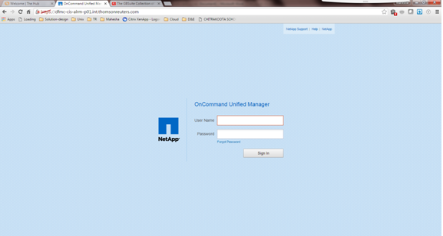

1. Click Storage > Clusters.

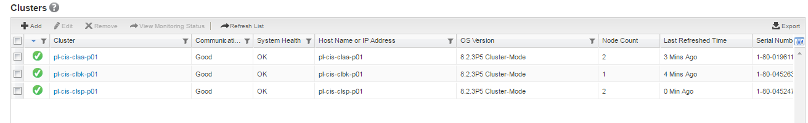

2. From the Clusters page, click Add.

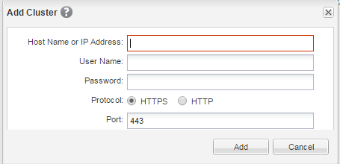

3. In the Add Cluster dialog box, specify the values required, such as the host name or IP address of

the cluster, user name, password, protocol for communication, and port number.

By default, the HTTPS protocol is selected.

4. Click Add.

5. If HTTPS is selected, perform the following steps:

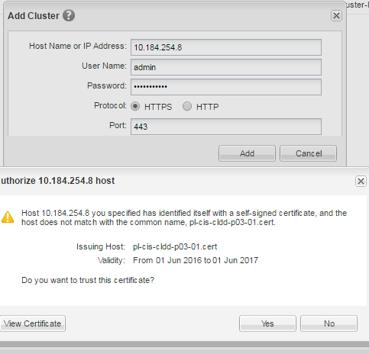

a. In the Authorize Host dialog box, click View Certificate to view the certificate information about the cluster.

b. Click Yes.

Unified Manager checks the certificate only when the cluster is initially added, but does not check it for each API call to Data ONTAP.

If the certificate has expired, we cannot add the cluster. We must renew the SSL certificate and then add the cluster.

6. Optional: View the cluster discovery status by performing the following steps:

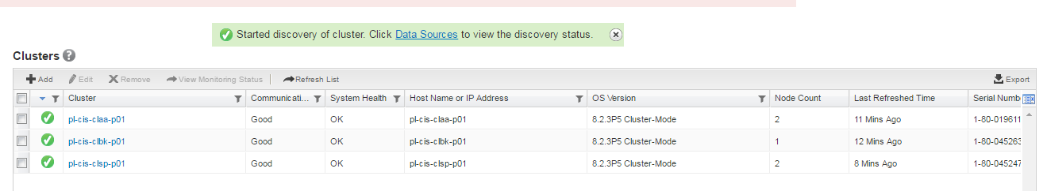

a. Click the Data Sources link from the discovery status message displayed in the Clusters page.

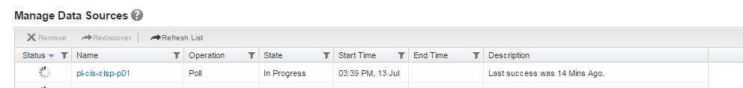

b. Review the cluster discovery status from the Manage Data Sources page.

Result

The cluster is added to the Unified Manager database after the default monitoring interval of approximately 15 minutes.

**1.2 Adding clusters to OPM 2.0**

**Requirements for adding a cluster to Performance Manager**

You must have all necessary configuration information available before adding a cluster.

Required information

• Host name or cluster management IP address (IPv4 or IPv6)

The host name is the FQDN or short name that Performance Manager uses to connect to the cluster. This host name must resolve to the cluster management IP address.

The cluster management IP address must be the cluster management LIF. If you use a node management LIF, the operation fails.

• User name and password to access the cluster

This account must have the Admin role with Application access set to ontap

• Type of protocol (HTTP or HTTPS) that is to be configured on the cluster and the port number of the cluster

Steps:

<https://dfmc-cis-perf-p01.int.thomsonreuters.com/#/login>

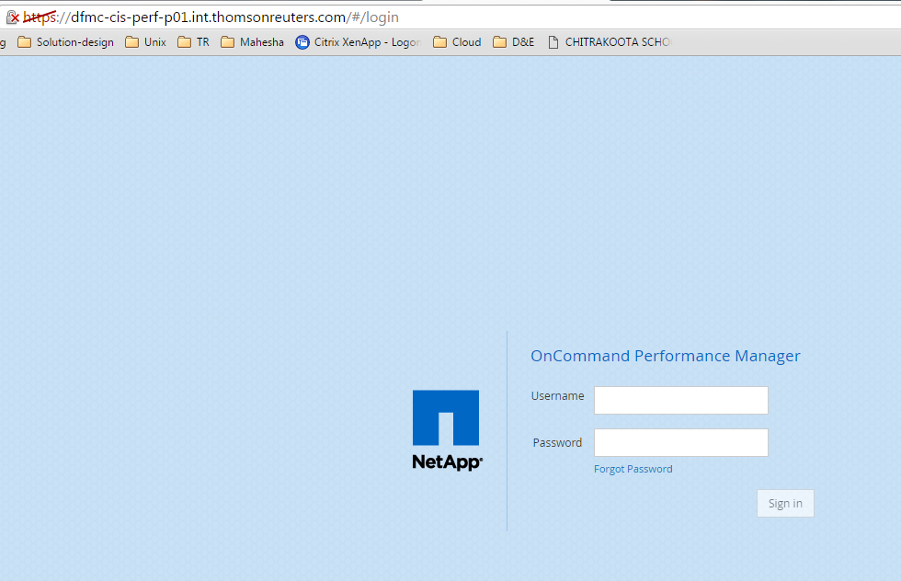

1. From the Administration main menu, click Data Sources.

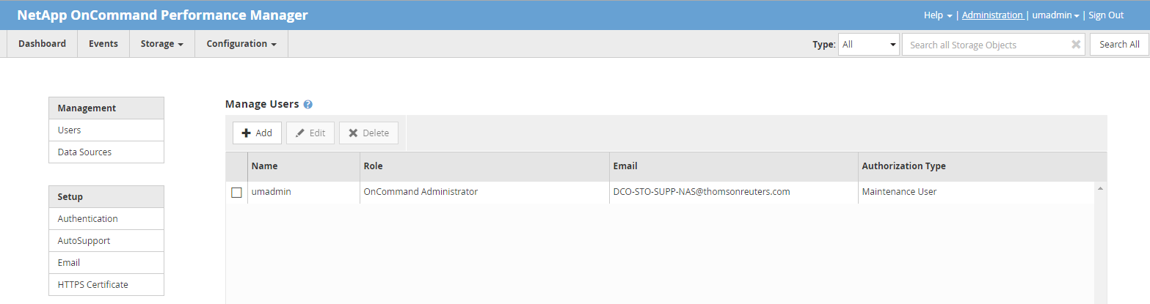

1. On the Manage Data Sources page, click Add.

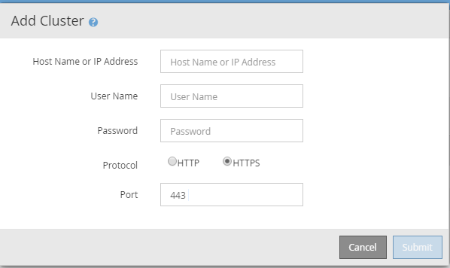

1. In the Add Cluster dialog box, specify the values as required, and then click Submit.

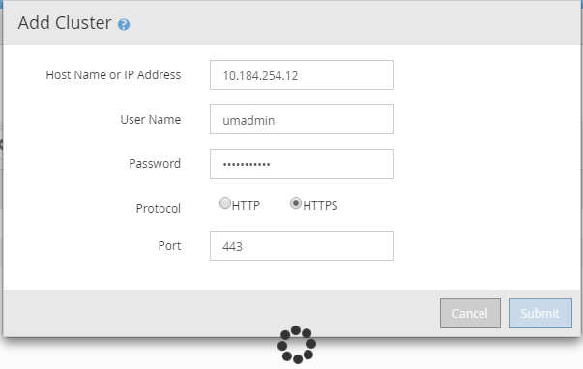

Result

The cluster is added to Performance Manager. After the initial cluster inventory and data collection has completed, which may take up to 30 minutes, performance statistics will display in the UI.